Software Design Document
for
Crazy Five

Team: Team-Alfonso
Project: Crazy Five
Team Members:
Alfonso Ruelas
Andrei Kondyrev
Pallavi Arivukkarasu
Syed Inshal Raza Naqvi
Tayyab Munir

Table of Contents
Document Revision History 4
List of Figures 5
List of Tables 6
1. Introduction 7
1.1 Purpose of the System 7
1.2 Architectural Design Goals 7
1.2.1 Architecture 7
1.3 Scope [not required] 8
1.4 Definitions and References [not required] 8
2. Software Architecture 9
2.1 Overview 9
2.2 Subsystem Decomposition 9
2.2.1 Game Engine 9
2.2.2 Controller 10
2.2.3 Player 10
2.2.4 Menu 11
2.3 Use Cases – Sequence Diagrams 12
2.3.1 Move Player 12
2.3.2 Spawn Enemies 13
2.3.3 Enemies Firing Lasers 13
2.4 Hardware/Software Mapping [not required] 14
2.5 Persistent Data Storage and Management [not required] 14
2.6 Access Control and Security [not required] 14
2.7 Global Software Control [not required] 14
2.8 Boundary Conditions [not required] 14
3. Subsystem Services 15
3.1 Services 15

Document Revision History
Revision Number | Revision Date | Description | Rationale
2 | 20210326 | Updates to section 1, 2, & 3 | Adding information
1 | 20210324 | Initial Creation | Initial Creation

List of Figures
Figure 1: Multi-Layered Architecture 9
Figure 2: Game Engine 10
Figure 3: Controller Diagram 10
Figure 4: Class Diagram 12
Figure 5: Move Player Use Case 12
Figure 6: Spawn Enemies Use Case 13
Figure 7: Enemies Firing Lasers Use Case 13

List of Tables
Table 1: Player Keys 11
Table 2: Hot Keys 11
Table 3: Services 15

Introduction
This Software Design Document (SDD) is intended to explain the design process of the new Crazy Five computer game. This technical document will follow the standards and infrastructure set but multiple standards organizations such as IEEE, and ISO.

Purpose of the System
The purpose of this SDD is to provide an overview for how the new Crazy Five will be designed and built. The SDD was created to ensure that we meet the requirements specified in the project requirements documentation set by all the stakeholders and follow existing maintenance management practices and tools. This SDD provides an explanation of the system architecture, software, hardware, database design, and security.

Architectural Design Goals
The Crazy Five video game will make use of the multi-layer architecture with special emphasis on Availability and Performance as design qualities.

Architecture
By using the multi-layer architecture, this project will be able to split up work between developers so to complete tasks more quickly and not risk developers overstepping on each other’s work.
This project will consist of the following layers:
- Presentation Layer
- Functionality Layer
- Application Core Layer

Design Qualities
The following design qualities have been identified by all stakeholders as being required.

Availability
Crazy Five will focus on having the game be available 100% once it starts. This means that once the game starts, there should be no crashes or failures that cannot be captures and handled.
The developers for this project will make it a priority to write code that will prevent the application from crashing or displaying failures to the users in a way that will need a restart of the game. This means that while the game is in play, any errors/faults/failures will be handing in a way that will keep the game play from stopping.
Special focus from the developers will be to handle exceptions and process them in a way that will not only handle the error but also to save the state of the game for future error troubleshooting.

Performance
Performance is, “all about time”. The Crazy Five development team will focus on any action that the user performs, whether it be a button click or a mouse movement, should be not contain any lag, as lag severely impacts game play.
Considering that they are only a few possible actions that the user can perform, these actions will be benchmarked and tested throughout the game while testing.

Scope [not required]
A brief description of the following sections will be outlined next.
Section 2
Section 3

Definitions and References [not required]
[Put any necessary definitions, acronyms, abbreviations, references here. ]

2. Software Architecture

Overview
As mentioned earlier, the Crazy Five project will utilize the multi-layered software architecture to design the game. The multi-layered architecture is the most widely used architecture and easiest to implement in an environment such as a video game.
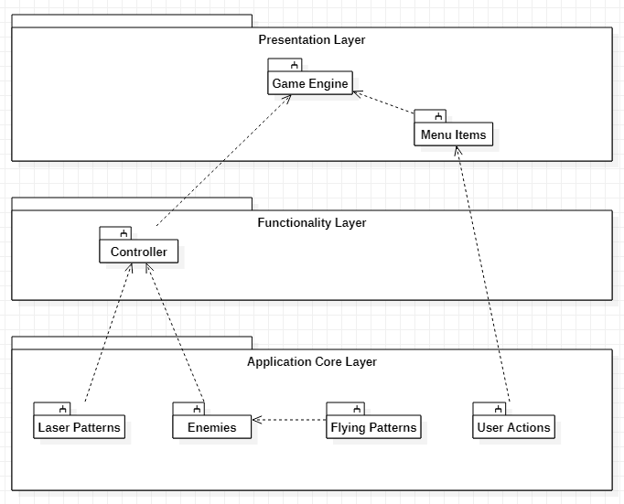
Figure 1: Multi-Layered Architecture

Subsystem Decomposition

Game Engine
The game engine is the entry point for the game. From this point, one can initialize the game settings, load content, draw, and update.
The GraphicsDeviceManager and SpriteBatch are used for the MonoGame engine, whereas the GameController and ActorFactory are developed objects to handle new logic.
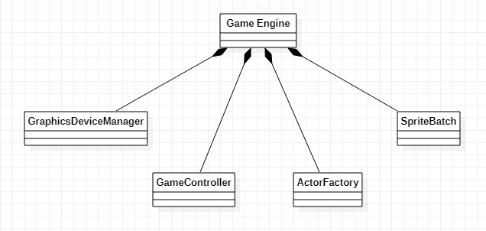
Figure 2: Game Engine

Controller
The controller will manage all aspects of the enemy’s actions, including creating the enemies, lasers, and the patterns that the enemies will use to move.
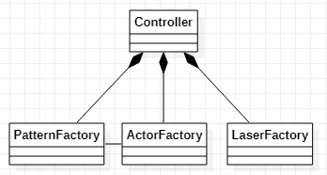
Figure 3: Controller Diagram

Player
The user actions subsystem will capture all user actions such as movements. At the time of this writing, the following button clicks are captured:
User Action | Description
Up Arrow | Move the player sprite up
Down Arrow | Move the player sprite down
Right Arrow | Move the player sprite to the right
Left Arrow | Move the player sprite to the left
Table 1: Player Keys
In addition to these basic moves, the player can also be moved diagonally (holding up and right arrow simultaneously, for example) across the screen, which gives us a total of 8 directions to move.

Menu
The user actions subsystem will capture all user actions such as button clicks. At the time of this writing, the following button clicks are captured:
User Action | Description
S | Slow the game down
K | Toggle auto-fire; On/Off
Spacebar | Fire Projectile
ESC | Exit Game
Table 2: Hot Keys

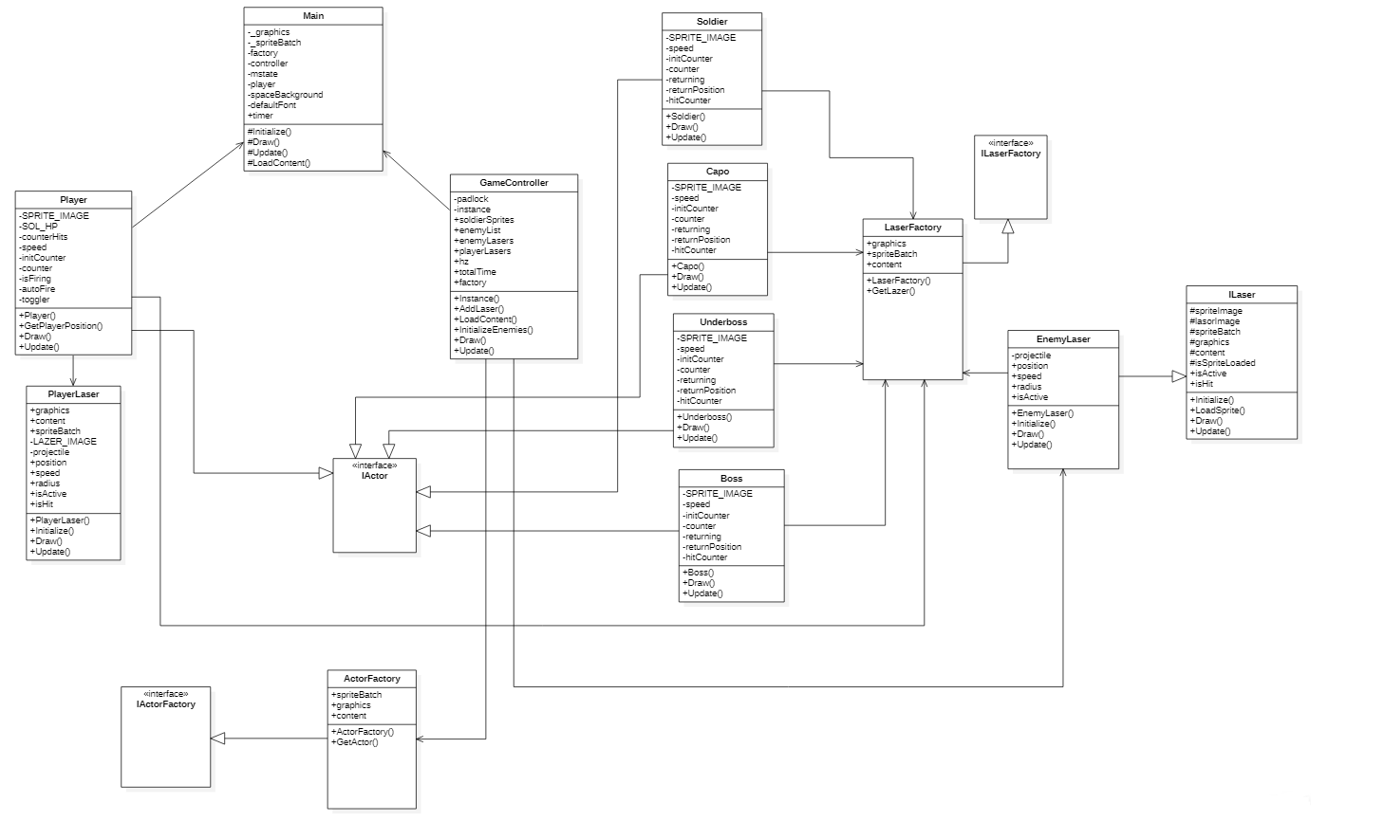
Figure 4: Class Diagram

Use Cases – Sequence Diagrams

Move Player
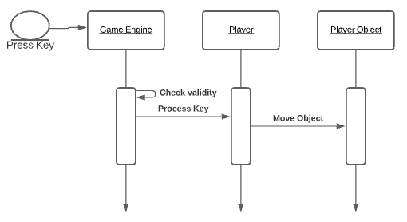
Figure 5: Move Player Use Case
As the user presses the key, the corresponding signal is sent to the player’s controller and in turn moves the player object on the screen.

Spawn Enemies
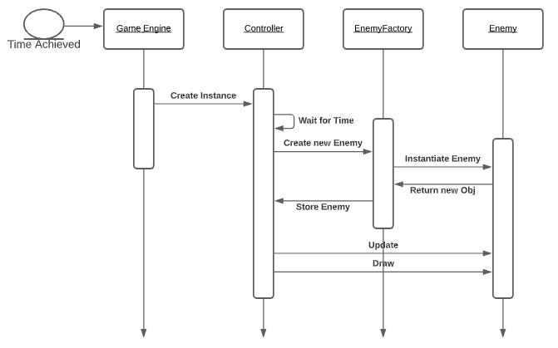
Figure 6: Spawn Enemies Use Case
As the game starts, the engine creates an instance where the controller creates all the enemy objects according to the value set in the config file and then the enemies are spawned.

Enemies Firing Lasers
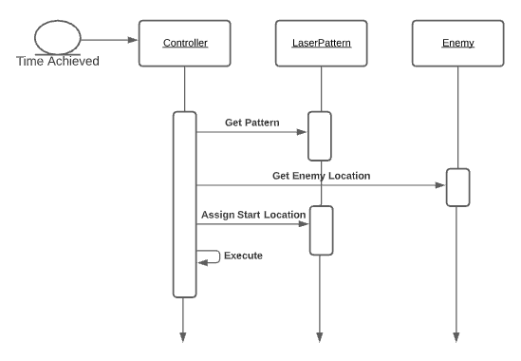
Figure 7: Enemies Firing Lasers Use Case
After the enemies are spawned, the controller gets the type of laser and laser pattern from the LaserFactory class and then the Enemy class defines the enemy’s location on the screen and starts firing lasers at the player.

Hardware/Software Mapping [not required]
[Describe how the subsystems are assigned to hardware and off-the-shelf components.
- Explain the allocation of subsystems to computers and the design of the infrastructure for supporting communication between subsystems. [optional]
- State the operating systems that run on the computers and any software component that are needed.
- Provide the UML deployment diagram that shows the allocation of subsystems to devices and execution environments. The nodes of the UML diagram will be the computers that run the subsystems (see Figure 7-21 in the textbook). [optional]

Persistent Data Storage and Management [not required]
[Describe the persistent data stored by the system and the data storage and management strategy used to store and manage those data.
- Identify the persistent data that need to be stored.
- Select a storage strategy. Briefly explain why you chose that storage strategy. Discuss pros and cons.]

Access Control and Security [not required]
[Describe the user model of the system in terms of an access matrix. Also describe the security issues, selection of authentication, the use of encryption, and the management of keys.]

Global Software Control [not required]
[Briefly describe how the global software control is implemented.
- How requests are initiated?
- How subsystems synchronize?]

Boundary Conditions [not required]
[Describe the start-up, shut-down and error behavior of the system.]

Subsystem Services

Services
The following section will contain the services contained within each subsystem.
Subsystem | Services
Menu Item | The menu service displays early in the game - it shows how to start the game and the options the player can use.  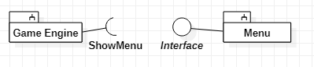
Controller | The controller service initiates the enemies and controls them based on the configuration file.  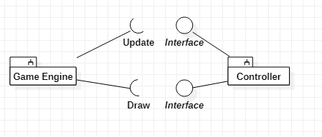
Player | The player service takes in keyboard inputs and processes them.  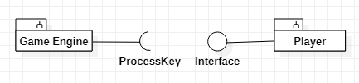
Table 3: Services

